CST 336: Team Project

By Roberto Palacios, Alex Rodriguez and Anna Rasburn

Trello Link: <https://trello.com/b/LQnpQ1C5/project-requirements>

User Story

Alice, a 15-year old teenager is obsessed with music. She wants to categorise her music into different playlists. She wants to search for songs from a database using a search where she can select what to search by e.g. she can search by song, by playlist, by artist. When she finds a list of songs, she want to choice to organise them in ascending or descending order. She finds the song she wants and clicks on it and it gives her more information like about the Artist of the song. On this page she can then add it to one of the 10 playlists on offer. She can then click on the playlist page and get a list of the songs in that playlist.

Database Scheme

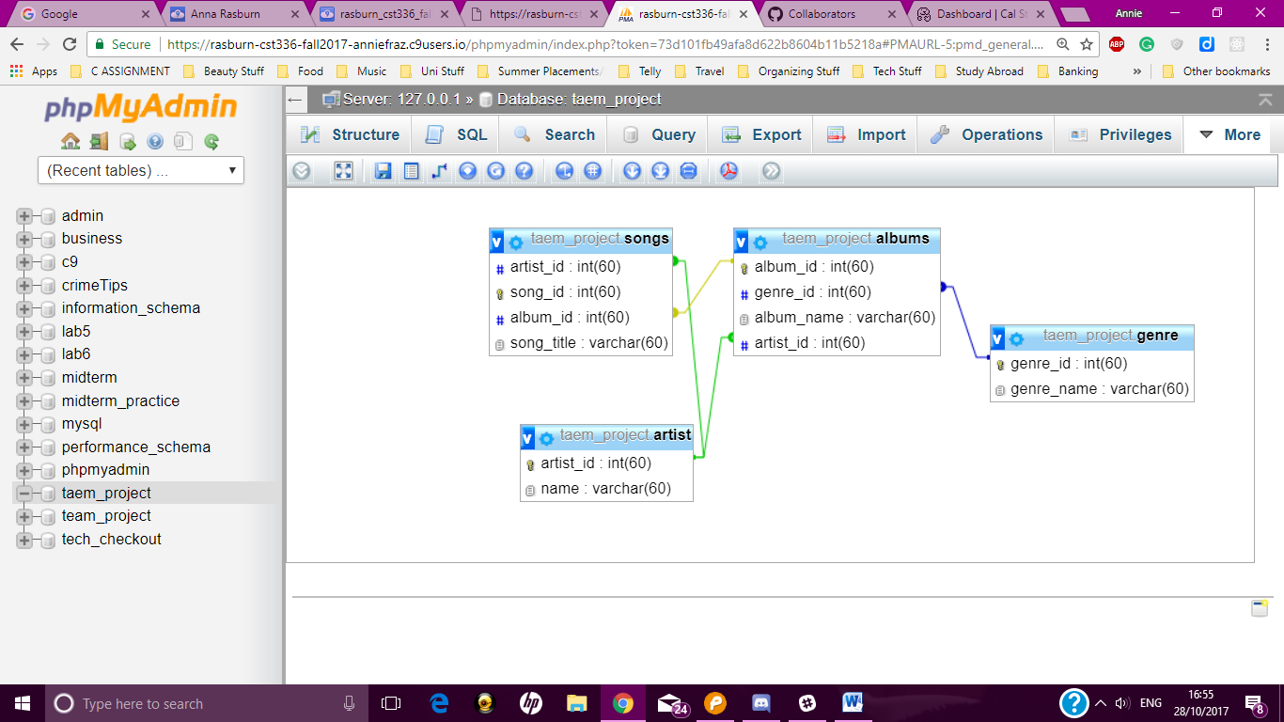

Mock Up

